EX. NO: 10
TITLE
Database with VIEW and INDEX
AIM
To create VIEW and INDEX on the given relation.

PROCEDURE
- Open MySQL Workbench and connect to the MySQL server.
- Select the MobileDB database.
- Display the records from the MobileSales table.
- Create a view using selected columns from the MobileSales table.
- Display the records from the created view.
- Create an index on the Price column of the MobileSales table.
- Display the index details to verify that the index was created successfully.
- Observe and verify the output.

COMMANDS
1. Select Database
USE MobileDB;

2. Display MobileSales Table
SELECT * FROM MobileSales;
3. Create VIEW
CREATE VIEW MobileSalesView AS
SELECT MobileName, Price, CustomerReview
FROM MobileSales;

4. Display the VIEW
SELECT * FROM MobileSalesView;

5. Create INDEX
CREATE INDEX idx_price
ON MobileSales(Price);

6. Verify the INDEX
SHOW INDEX FROM MobileSales;

7. Display the View Definition
SHOW CREATE VIEW MobileSalesView;
OUTPUTS

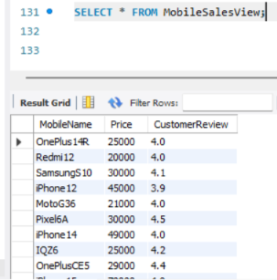

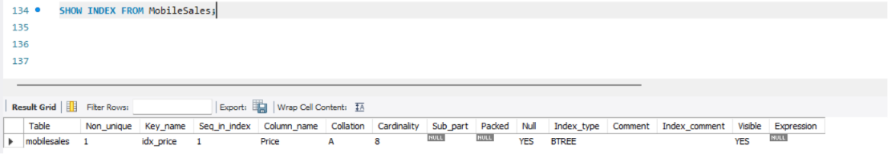

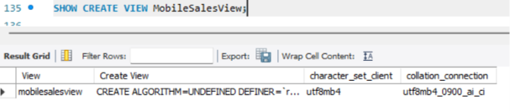

RESULT
Thus, the VIEW and INDEX were successfully created and verified on the MobileSales relation.

